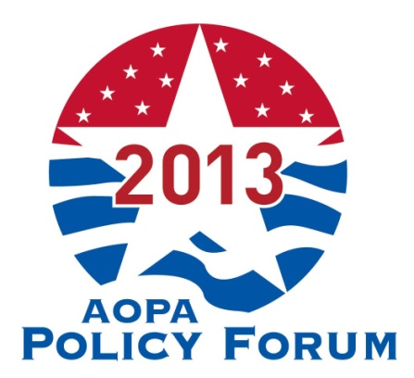

How to Register
Click Here to Register online. It’s an easy and efficient way to complete your registration.

Register by fax by completing one registration form (see below) for each attendee. (Make as
many copies as you need.) To register by fax, payment must be made by credit card. Complete the registration form and include your VISA or MasterCard information and fax to 571/431-0899. To avoid duplicate charges, please do not mail your form after faxing it.

To register by mail, complete the registration form (see below) and mail it with your payment by
check, money order, or credit card to: AOPA Policy Forum, 330 John Carlyle Street, Suite 200 Alexandria, VA 22314. (Please note that mailed registrations may take longer to be received and processed.) Registrations will not be processed without payment.

Acknowledgements confirming registration will be e-mailed to each registrant. Please read this confirmation carefully. If corrections or changes are needed, note them on the confirmation and return it to Steve Custer by March 5th, 2013. Fax to 571/431-0899 or call 571/431-0876 with changes.

Payment
Registration forms must be accompanied by full payment in U.S. funds in order to be processed. VISA, MasterCard, checks and money orders are accepted for payment. Checks should be made payable to AOPA and must be drawn on a U.S. bank.

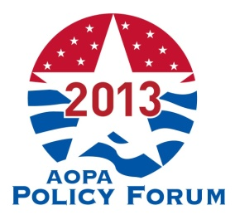

Registration Form
L’Enfant Plaza Capitol Hill – Washington, DC
March 12th – 13th, 2013
2013 AOPA Policy Forum
(Please use one form for each attendee)

Last Name First Name Title / Credentials

Company

Street Address

City State Zip

Telephone Number Fax Number E-Mail (For confirmation purposes)

___________________
Home Zip Code (needed to locate your Congressional District) Cell Phone Number

Registration Fee: □ Per Person: $125

Payment Options: □ Visa □ MasterCard □ AmEx □ Check

________________________________________________________________________
Credit Card Number Exp. Date

________________________________________________________________________
Name on card (please print) Signature

Special Accommodations Required: □Yes □No (If Yes):

Please check one:
□ I will be staying at the L’Enfant Plaza.
□ I will not be staying at the L’Enfant Plaza. (I will be staying at )
(Attendees are responsible for making their own hotel reservations. Call the L’Enfant at (202) 484-1000 and ask for the AOPA room block.)

Have you attended the O&P Policy Forum or a Legislative Conference in the past?
□ Yes If yes, how many? □ 1 □ 2 □ 3 □ 4 □ 5+
□ No, This is my first Policy Forum

Fax Registration form and payment information to 571/431-0899, or mail form with payment to:
AOPA Policy Forum, 330 John Carlyle Street, Suite 200 Alexandria, VA 22334
Questions? Contact AOPA at 571/431-0854 or dbernard@AOPAnet.org.

