SUBMISSION GUIDELINES FOR THE 2018 AOPA National Assembly

Teri Kuffel, JD¹ Rick Riley², and Jim Weber, MBA ³
¹AOPA National Assembly Co-Chair, USA, ²AOPA National Assembly Co-Chair, USA, ³AOPA president, USA, Assembly@AOPAnet.org
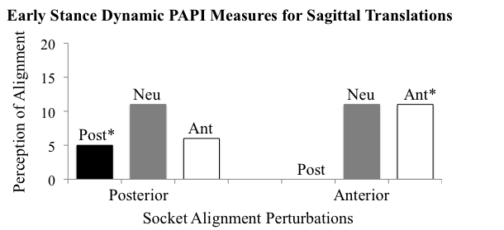

INTRODUCTION OR PURPOSE
AOPA and organizing partners have made a commitment to having a strong scientific program at the upcoming meeting. The program committee is soliciting scientific and clinical case study abstracts for the upcoming meeting Sept 26-29, 2018 in Vancouver, BC, CANADA. This document will provide information about the abstract submission process and serve as a model for the abstract format. Abstracts must reflect original research that has not been presented previously. Abstracts may be submitted between now and March 1, 2018. They will then be reviewed by the conference program committee. Authors will be notified in Mid-April, 2018. Additional information along with a complete timeline can be found at www.AOPAnet.org

METHODS
All abstracts for the 2018 Meeting must be submitted electronically via the submission website via the link found at www.AOPAnet.org. All submitted abstracts must be Portable Document Format (.PDF) and are limited to one page. A full version of the abstract must be submitted, and a blinded version must also be submitted, with all identifying information removed. The title (in bold caps), authors, and author affiliations should be centered across the top of the first page. Use numerical superscripts to distinguish authors from different institutions. An e-mail address for one author should be included. Optionally, a web address of department, laboratory or author may be included. The body of the manuscript should be divided into the titled sections.

RESULTS
Text within the document must be 10-point Times or Times New Roman. Graphs and tables may be incorporated within the document, especially if they enhance the value of the abstract. Include a label below the figure (Figure 1). Text within such elements should be clearly readable. If data tables are used to convey research results, include a title and caption above the table. Color is acceptable in figures² if it adds to the clarity of the information, and the abstracts will be available online in PDF format. Reference citations within the text are to be made using numbers^{1,2}. A reference section is to be formatted as illustrated on this page. Acknowledgements are optional, and should be placed in their own section if included.

Figure 1. Include a caption beneath figures as shown. Use superscript numbers for references¹.

CONCLUSION
Strong scientific and clinical case study submissions are expected from the world over. The format of the conference will provide a substantial audience for novel research focused on orthotics and prosthetics. The committee anticipates more than two hundred abstract submissions. The Congress will bring together prosthetists, orthotists, physicians, scientists, researchers, engineers, programmers, clinicians, and other professionals.

SIGNIFICANCE
The organization has made a commitment to have extraordinary plenary sessions with invited speakers who are leading experts from the world over. This diverse community of professionals focusing on different aspects of orthotics and prosthetics will provide a unique and powerful environment to advance the field forward. The venue is extraordinary with spacious rooms at reasonable rates. Students are also encouraged to submit abstracts to the AOPA National Assembly and special room rates are available, as well as possible financial support for select students.

REFERENCES
1. Boone DA, et al. J Rehabil Res Dev; 49, 843-54, 2012.
2. Takahashi KZ & Stanhope SJ. ASB Annual Meeting, Boston, MA, USA, 2015.
3. Woltring, H. Biomechanics of Human Movement, pp. 203-237, 1990.

DISCLOSURE
Authors should disclose any potential conflicts of interest in their abstract. Abstracts from industry are encouraged, and students wishing to present their novel prosthetic and orthotic designs to leading industry engineers are encouraged.

ACKNOWLEDGMENTS
This work was funded by the AOPA National Assembly

